Lacoochee Elementary Reading Drama Club Presents……

“The Unhappy Princess”

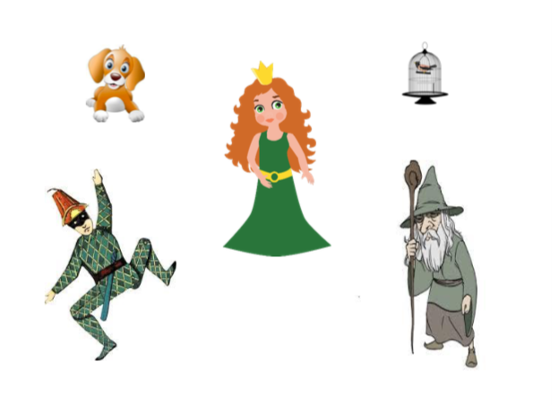
Wednesday, January 30,2019
Location: Cafeteria
First Show time 2:00pm
Evening Show time 5:30pm
Please check in the front office for a visitor’s pass for the first show.
Please come out and show your support to our 2nd and 3rd graders!!

